|  |
| --- |
|  |

**Pre-Vocational and Vocational training centre for Children with Special Needs at Mahesana**

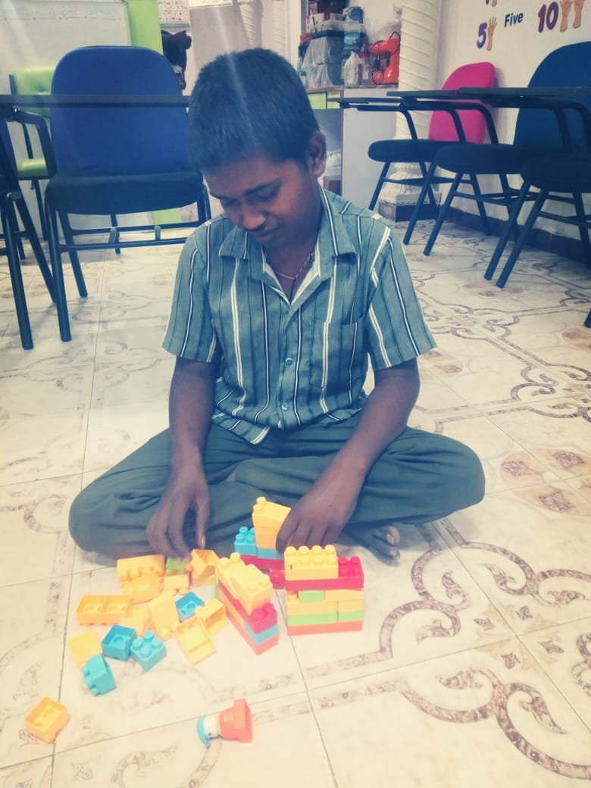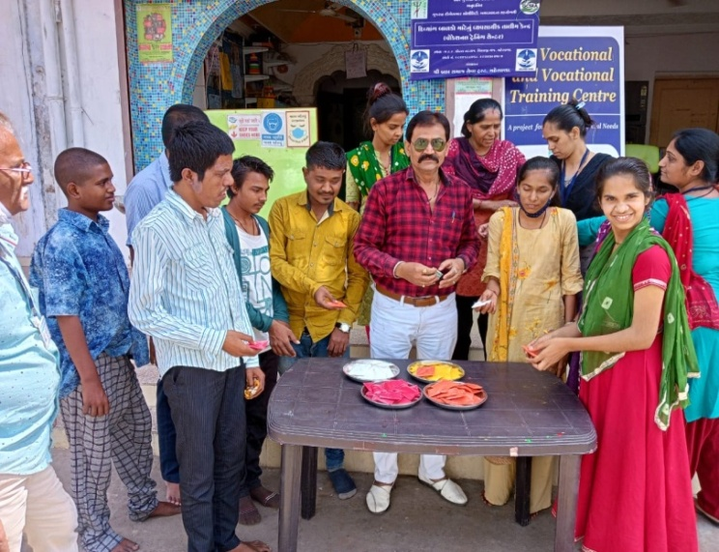

**Project Completion Report**

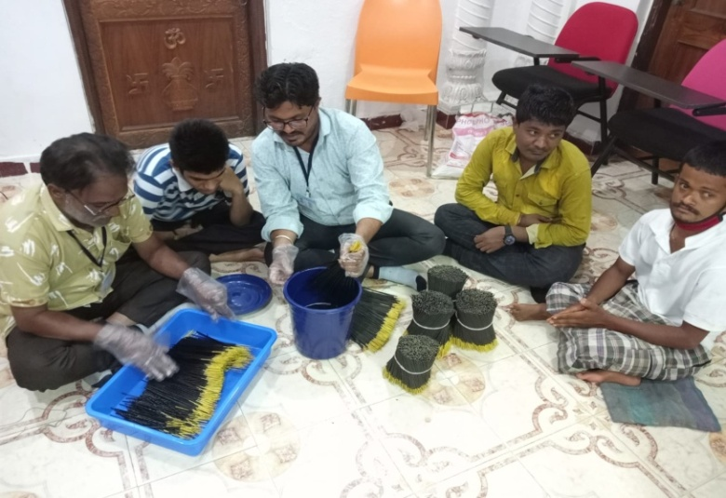

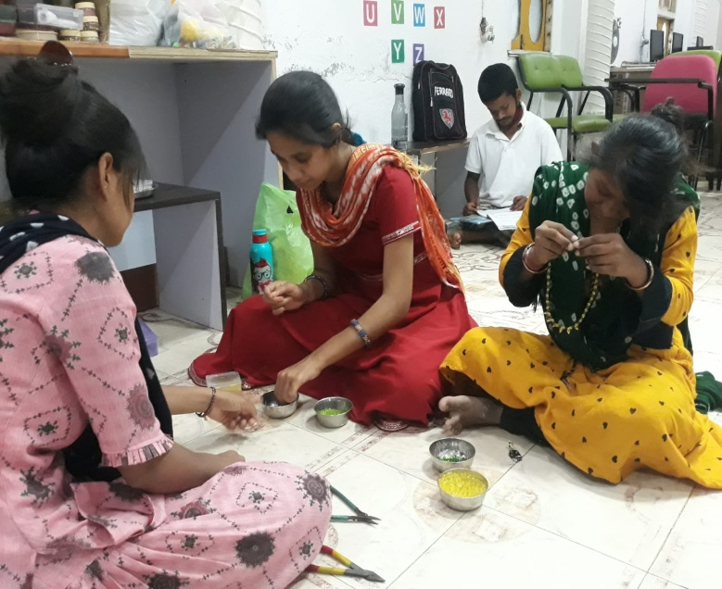

**Implemented by**

**Shri Brahm Samaj Seva Trust**

**F- 12, Rajendra Estate, Opp Gayatri Temple, Mahesana**

Table of Contents

Major Objectives 3

Major Parameters 3

Major Completed Activities 4

Quarter 1 October, 2021 to January, 2021 4

Set Up a centre 4

Students Enrollments 4

Quarter 2 - February, 2022 to April, 2022 5

Holi Celebration 6

Paper making of the different size 7

Agarbatti Making 8

Quarter 3 - May, 2022 to July, 2022 8

Quarter 4 - August, 2022 to October, 2022 11

Rangoli making and Color work on Diyas 12

Selling Centre 13

Work Summary 14

Project Team 14

Details of the Parents 15

Conducted Various Activities at the Centre 16

Students Feedback 16

# Major Objectives

* To create a sense of self reliance and financial independence amongst youth with disabilities one stop centre for all Special children/Adults and make people aware about issues related to special children through various medium of communication
* To provide qualitative and holistic training to children with special needs and impart vocational skills which will enable them to earn and lead a purposeful life
* To sensitize the public parents of special children about needs of special children and the way to manage it.

## Major Parameters

|  |  |
| --- | --- |
| Issuance of the work order | 22nd October, 2021 |
| Work order duration | 01 year |
| Project cost | Rs.32,46,000/- |
| Project Location | 7,8, 9 – Hotel Natraj , Shivaji Ganj, Mahesana |
| Average Number of trainee | 19 |
| Submitted Monthly Report | 12 |
| Project Cost | Rs. 25,03,080/- |

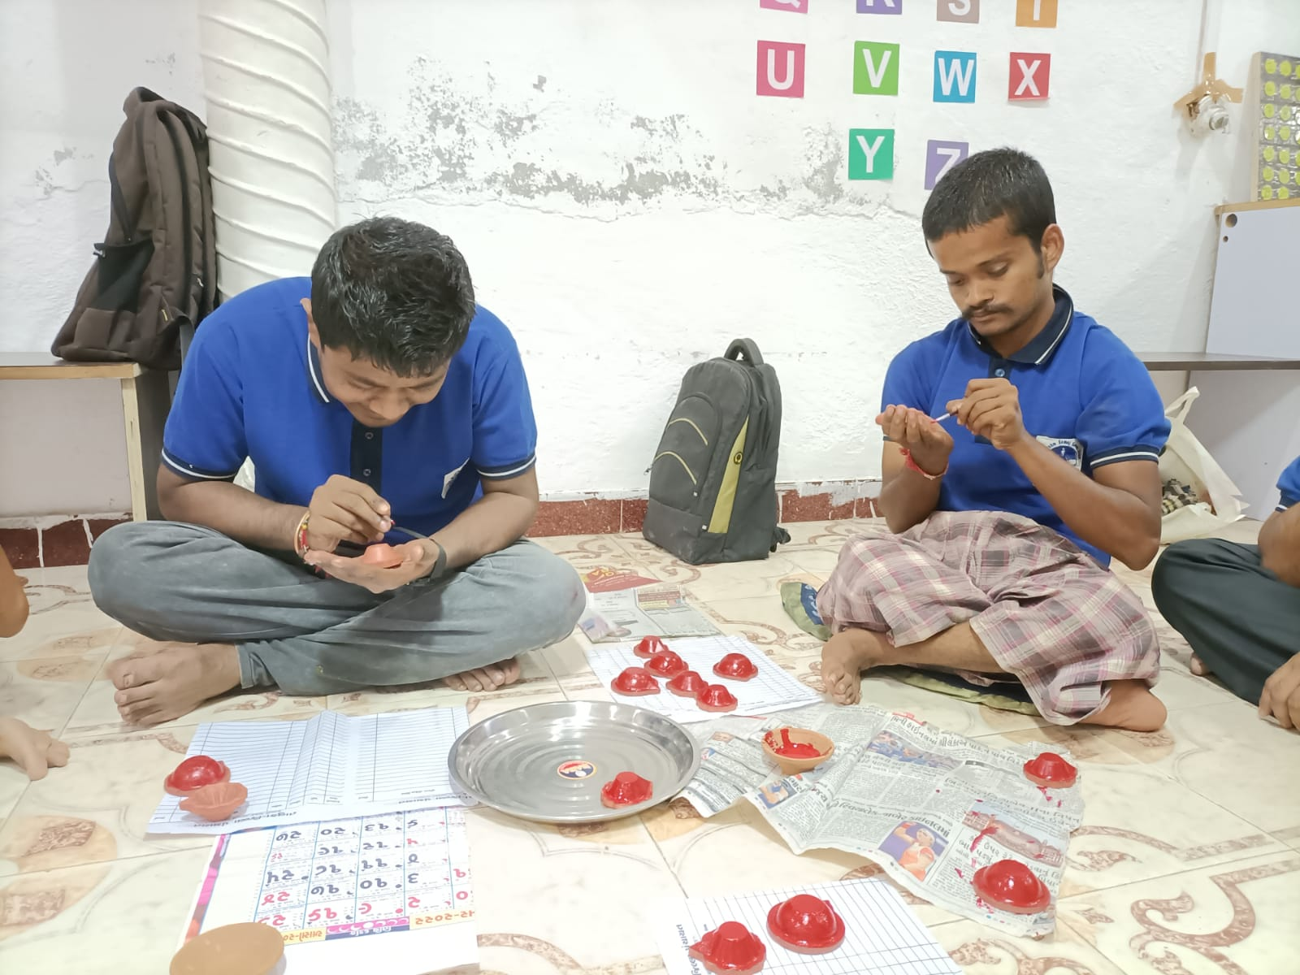

# Major Completed Activities

## Quarter 1 October, 2021 to January, 2021

### Set Up a centre

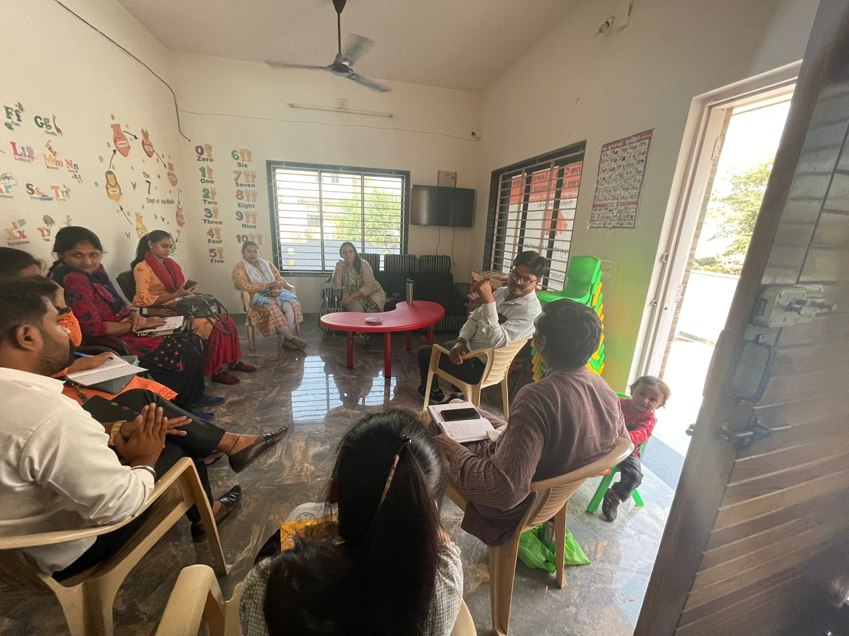

* Have submitted the Indemnity Bond as per the instruction
* Identification and Finalization of the Location at Mahesana area
* Identification and Procurement of the Equipments require for the centre through various vendors
* Advertisement and Recruitment of the Team
* Capacity building of the Team were also conducted at the Gandhinagar Centre

### Students Enrollments

* Visited Schools , nearby areas and Government offices to make them aware about the centre

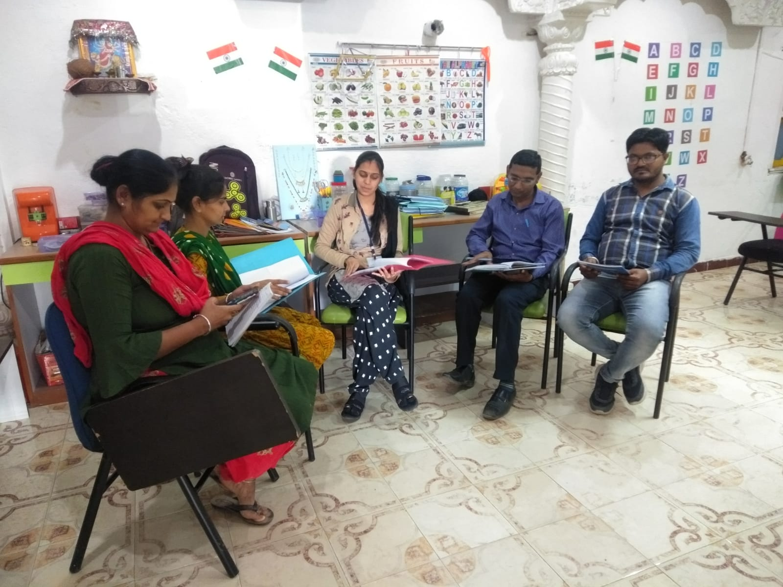

* One to one discussion were carried out with the parents, case history if the students were discussed
* Health assessments reports were also carried out and stored all data digitally
* FACP (Functional skills) Assessment was carried out on each student to understand their baseline and to tailor their prospective program
* Vocational Assessment (NIMH) was carried out on each pupil to understand their baseline and to tailor their prospective program.
* Identification of the pre vocational program which includes money skills, reading time and social etiquettes for few initial months.
* Measuring the developments of each students, the next vocational training was identified

## Quarter 2 - February, 2022 to April, 2022

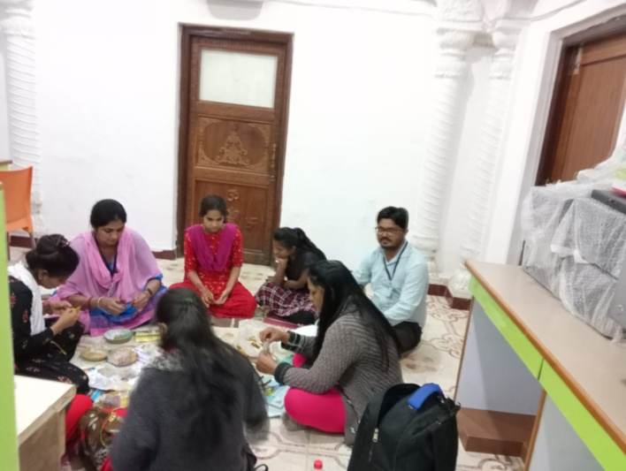

* 11 Students were enrolled in this quarter and transportation was arranged to pick up and drop for all students
* Market survey was planned and carried out in this month also
* This activities help us to make them aware and strengthen the relationship with the community

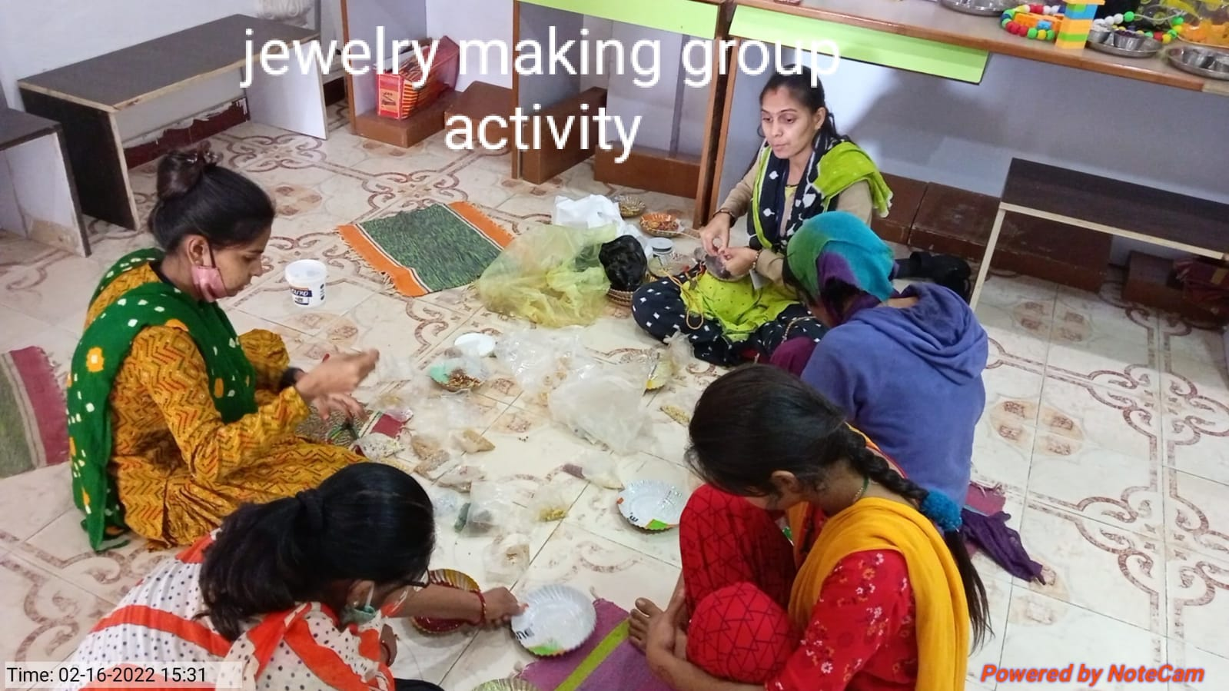

* Procurement of the raw material such as for jewelery making and paper bags , etc. were carried out
* Capacity building of the staff for jewelery making was also conducted
* Simultaneously, approach for the parents were also carried out and many of parents visited the centre regularly

## 

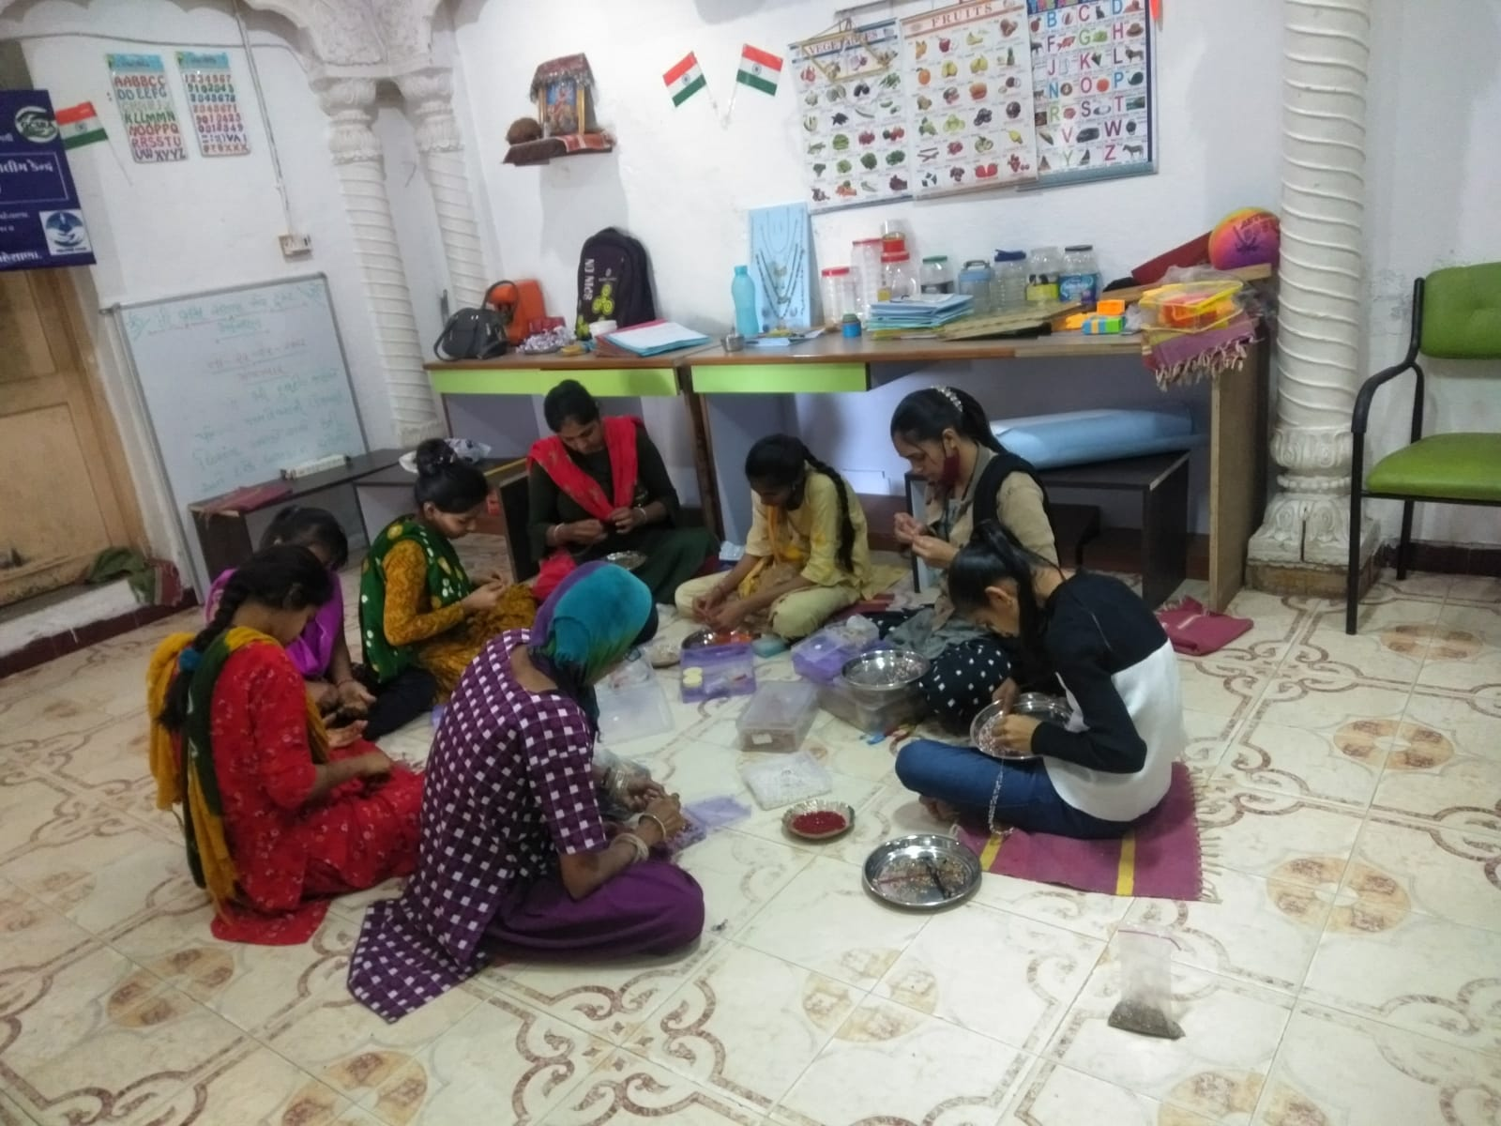

* In this month , total students of the centre was 12
* Vocational training of the phase II i.e. Paper bags making was started
* The training to write their names and phone numbers was also carried out on regular interval
* After the market survey, team had decided to introduce two more vocational training such as Divet Making and Coffee making

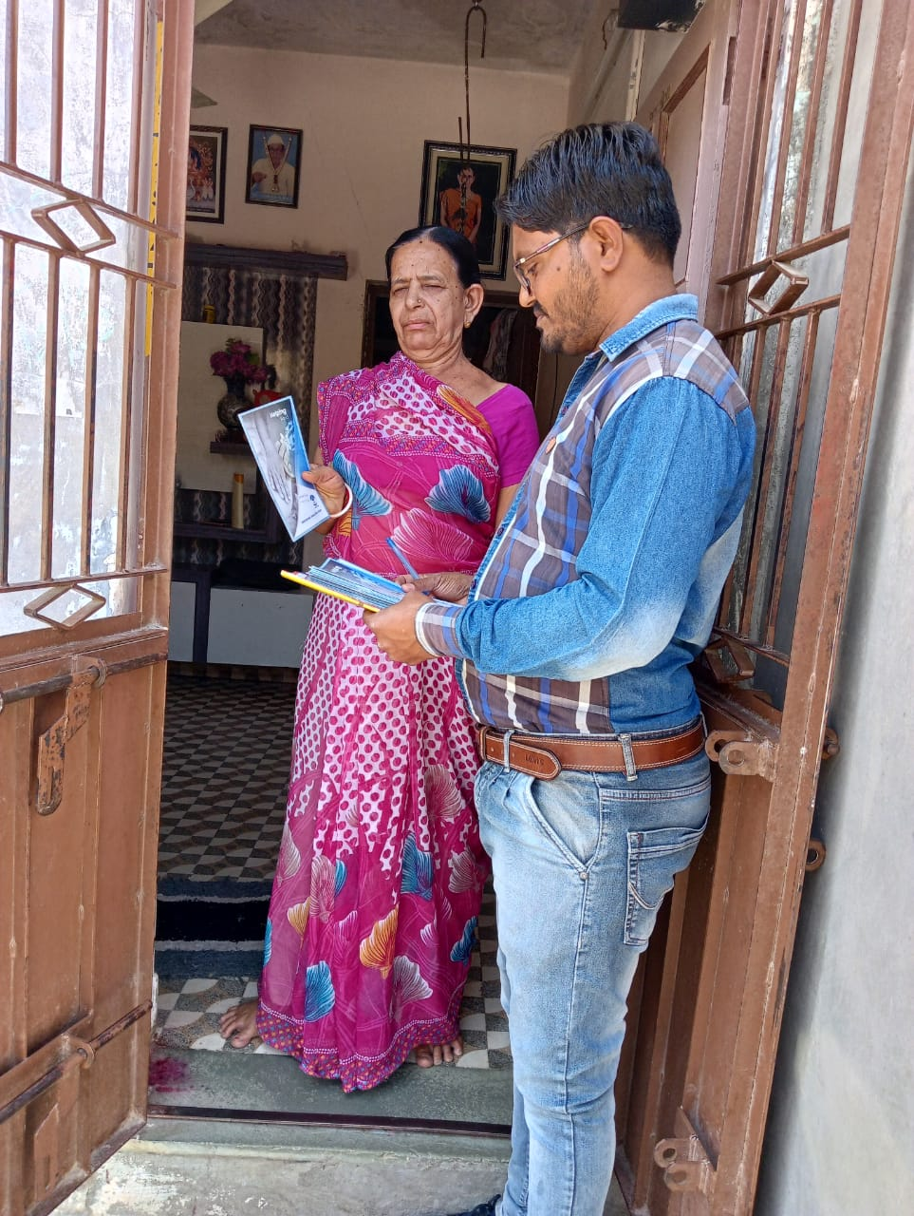

* The training was planned and procurement of the equipments were carried out
* The each training was divided into small components and the checklist was prepared of each components
* Functional academics were imparted through various methods such as flash cards, tangible objects.
* Home visits and door to door awareness meetings were conducted to understand the needs and aspirations of working parents for their ward.

### Holi Celebration

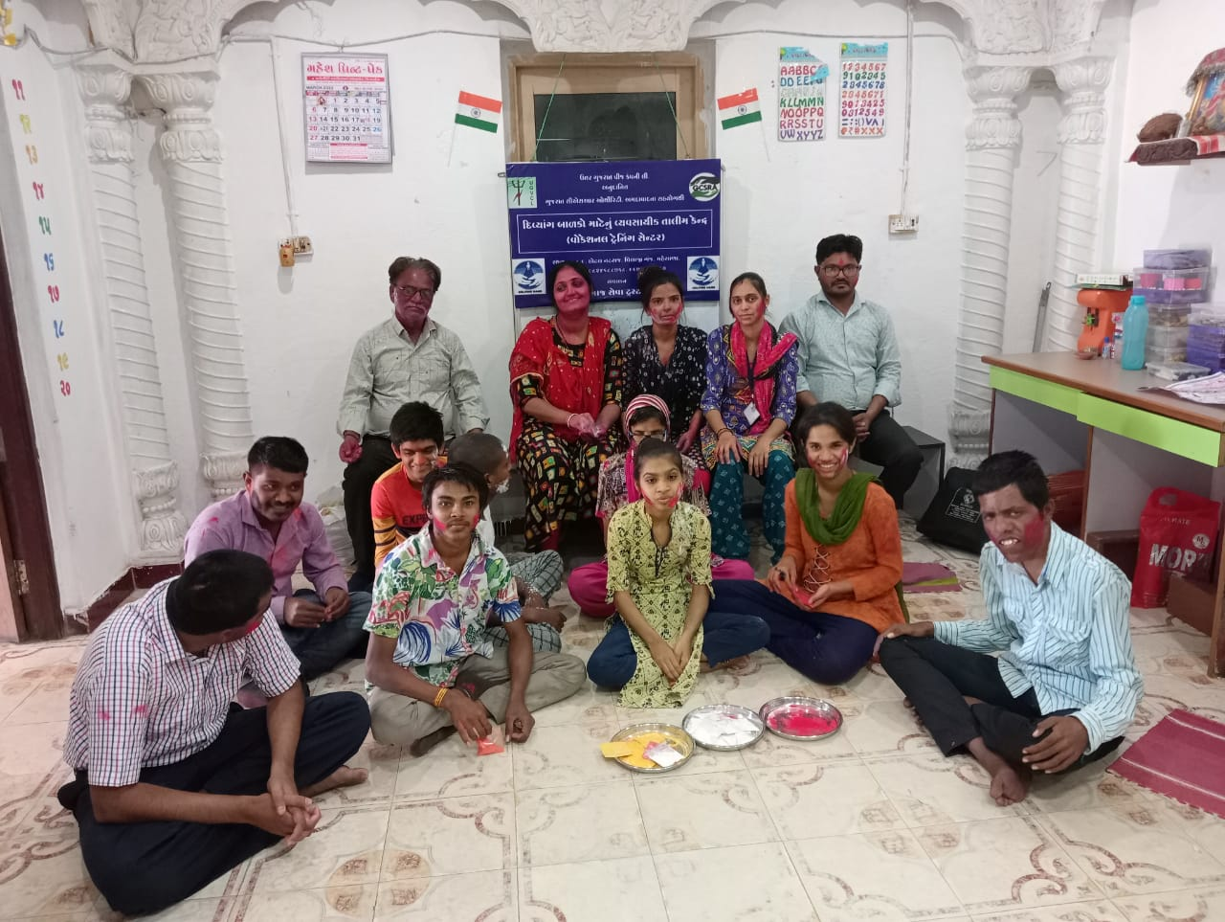

* Various social events were carried out for trainees to understand the festivals and importance of cultural events.
* Trainees were encouraged to interact socially with appropriate etiquettes with visitors.
* Trainees were imparted functional skills during the social events through stories/tales and real life examples. Trainees found that the interaction was very entertaining and learning exercise

### Paper making of the different size

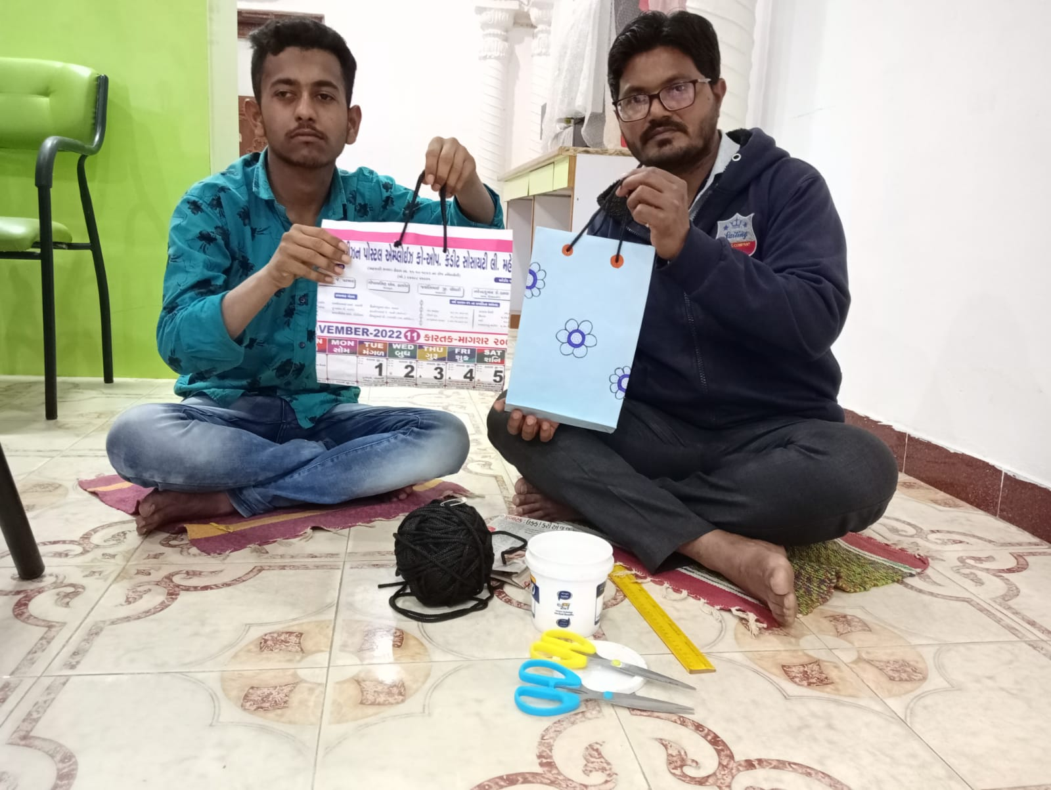

* Trainees were trained to make different sizes templates and stencils to cut and make paper bags of different sizes.
* These sizes were finalized after the understanding the need of the markets and the usability by different consumers.

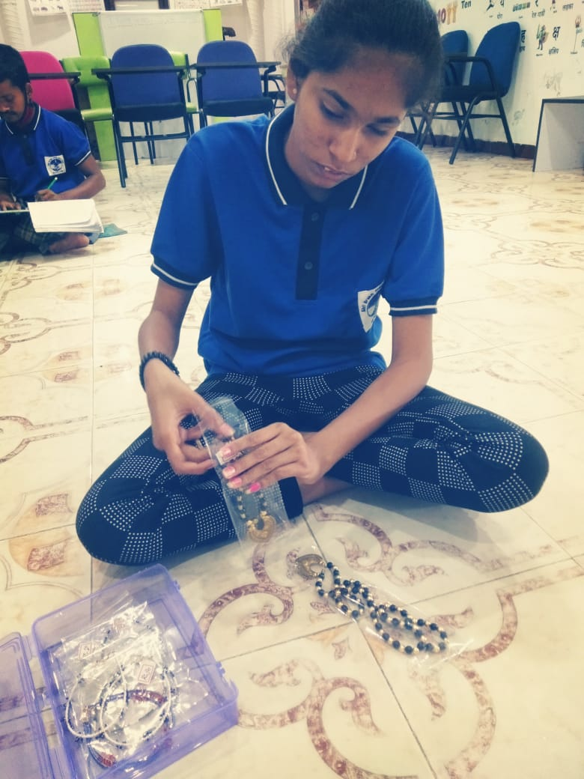

* Trainees had started to make paper bags and the selling was planned at nominal charges as a trial in the first phase.
* Total 14 trainees was accessing the centre for Pre Vocational and Vocational training

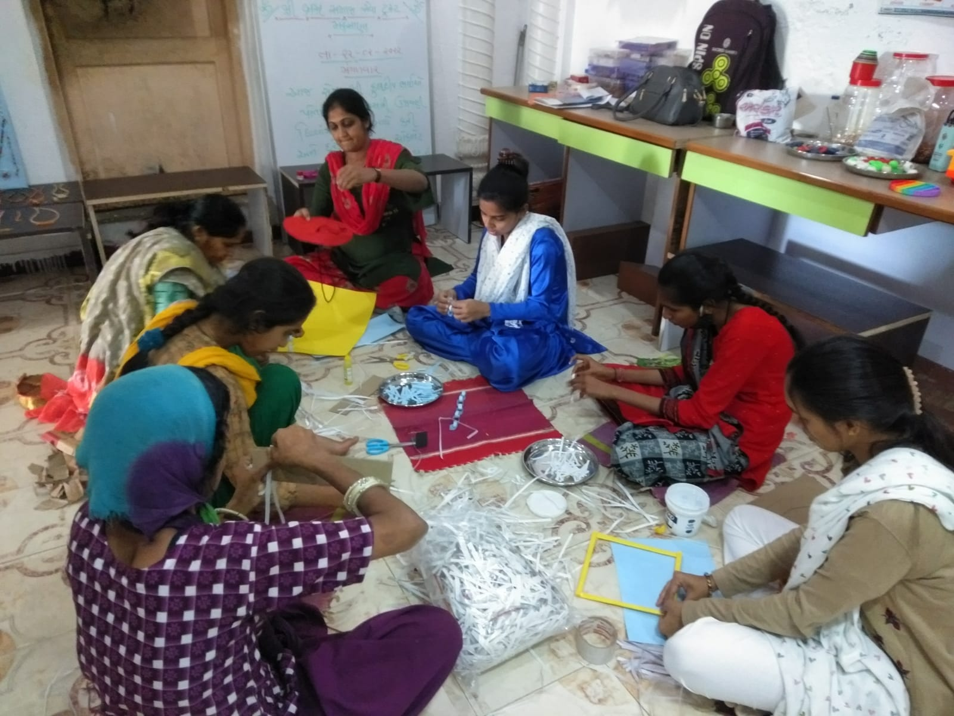

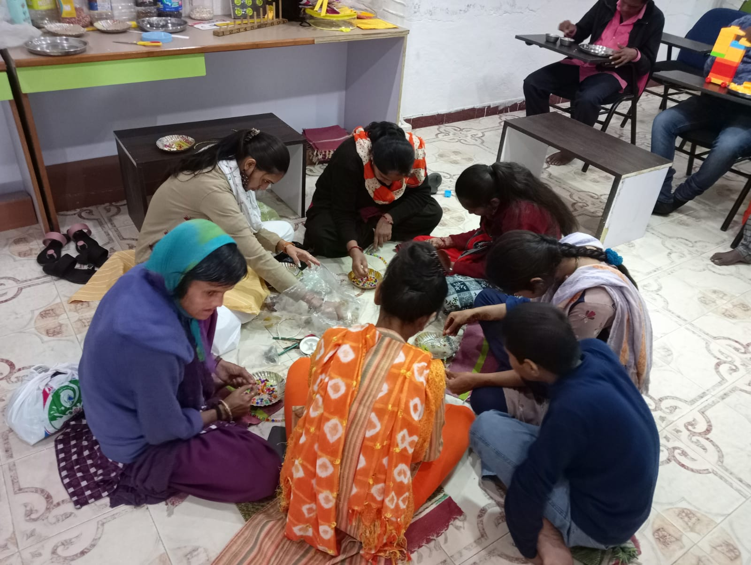

* Parents were kept informed of the developments and the trainee’s progress was often shared as and when parents are keen to know about.
* Community interaction and collaboration were developing and got positive results with the neighborhood vendors and stores.
* Fitness and wellbeing sessions were conducted with yoga and movement as the key areas of focus.

### Agarbatti Making

* Individual batches were identified for the training and carried out training for the essence sticks and its packaging.

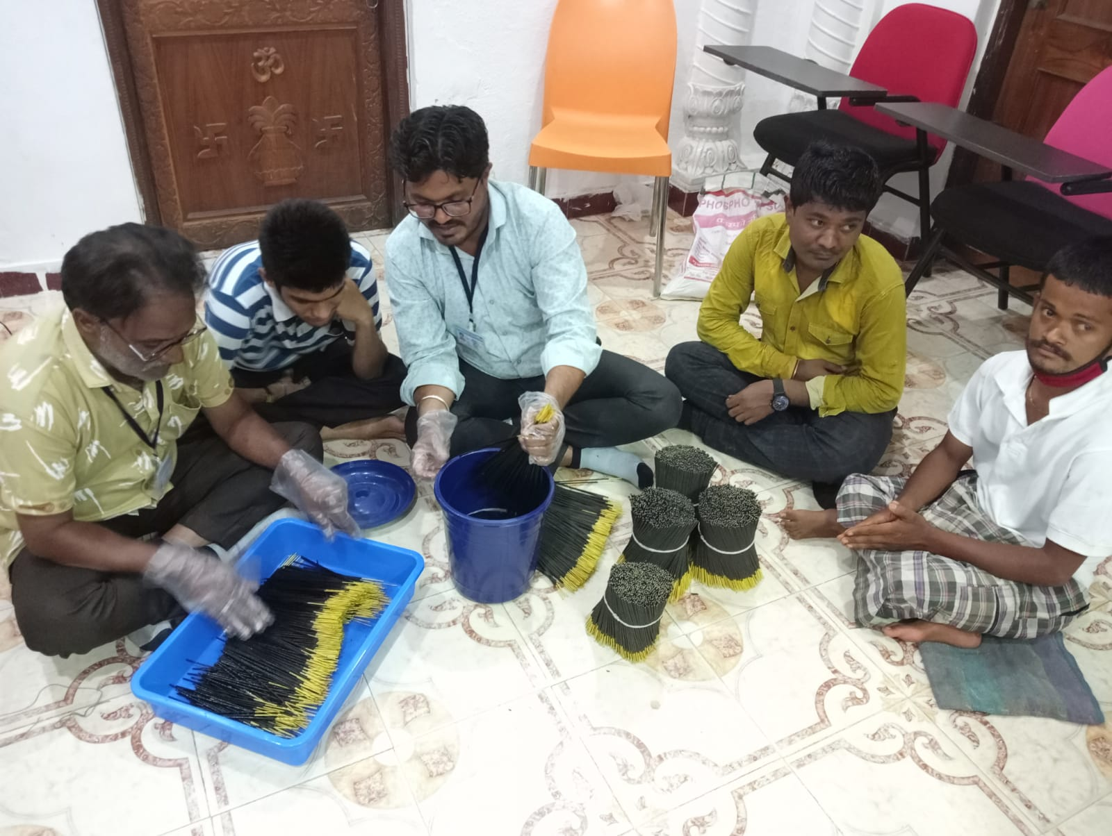

* This training were also divided into dipping of the bundle of sticks into the fragranced solution, and there after dried and packaged.
* Trainees were trained on how to count numbers this exercise was enable them to make bundles of equal numbers.

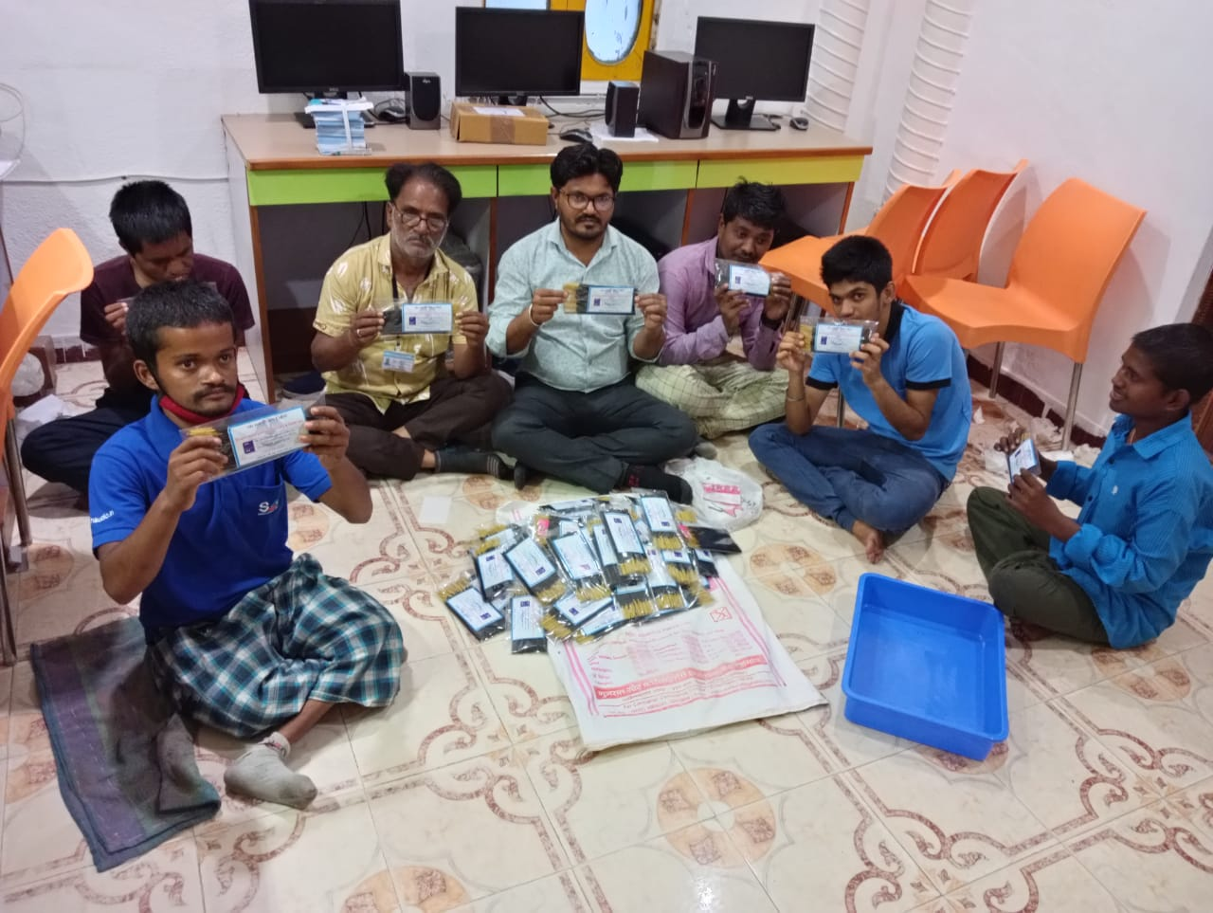

* Health and safety is equally important and trainees were also taught about the precautions this procedure entails.
* The objective of this training was making the bundles and catering to the selling outlets in the neighborhood.

## Quarter 3 - May, 2022 to July, 2022

* Ornaments was made by our trainees and sold at Hastkala Haat in Patan
* Around Rs. 5500 was generated through this stole in the first attempt

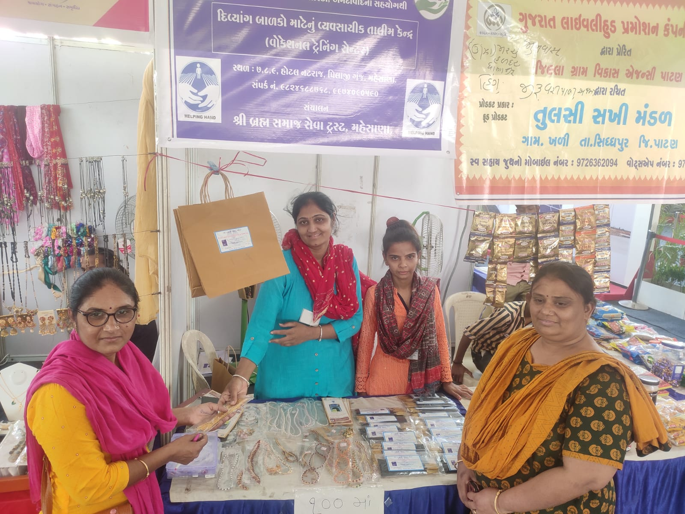

* The physical health check up and Cataract surgery at Mahesana Civil Hospital was assisted by the team
* Trainees were provided with various fine and gross motor exercises on daily basis, this enables them to perform different tasks using pincer grasp.

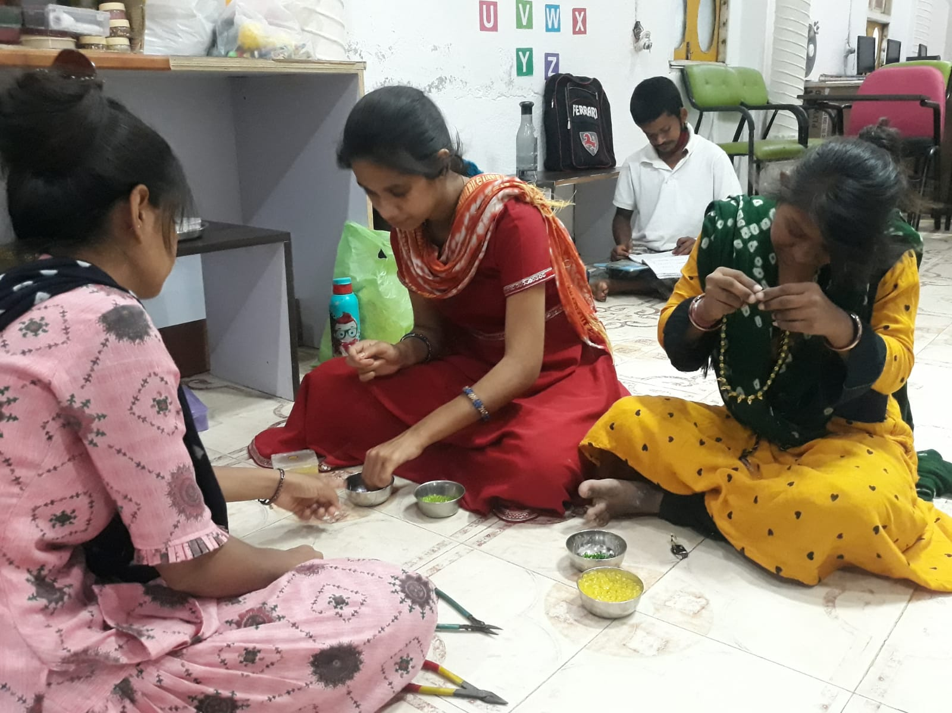

* Trainees were able to fold paper at various dimensions and measurements, use needle and beads – regular and repetitive practice makes them confident in performing these activities at ease.
* Color concepts were reinforced so the pattern was followed in the making of jewelry

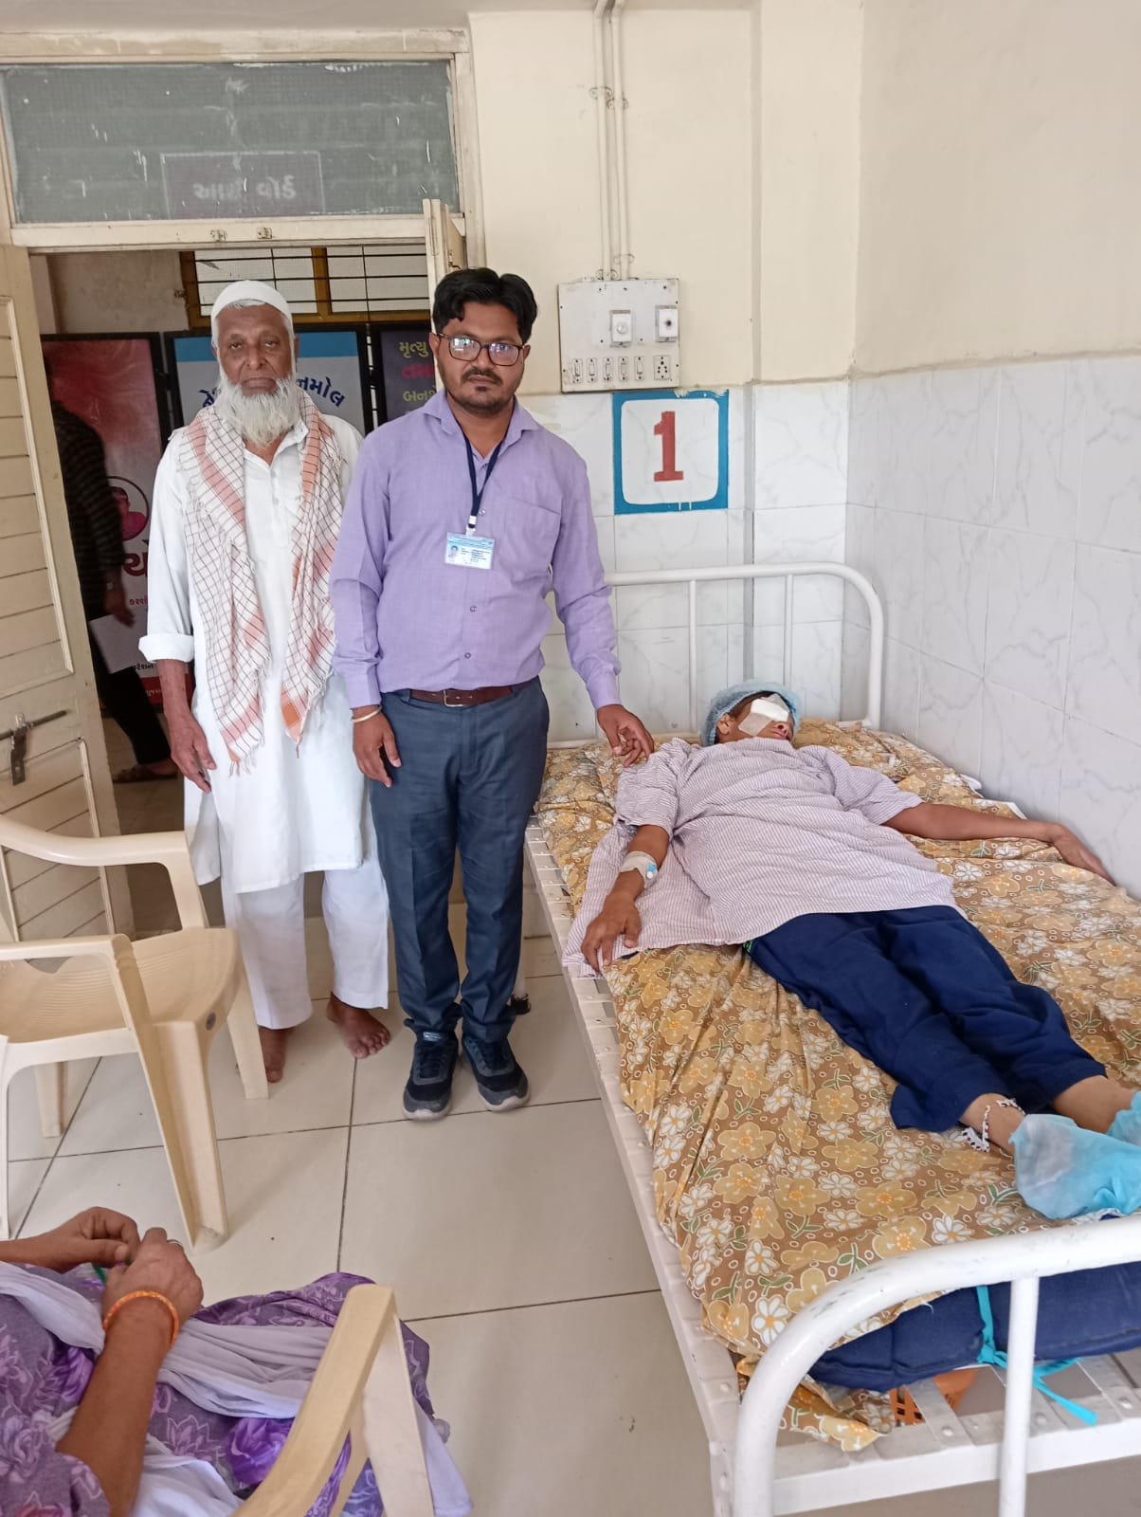

* Team had also visited dead and mute school of Mahesana and also various pockets of Mehsana such as Visnagar Road, Bahubali Road, Radhanpur Circle) were visited to spread awareness towards Special Needs and Disabilities.
* As a result of these visits, enquiries were received at the centre for enrollments.
* As a part of community outreach, one of our trainee Mr Sodha Mahipat Singh, was given a modified bicycle to support him in selling his products more efficiently and in timely manner.

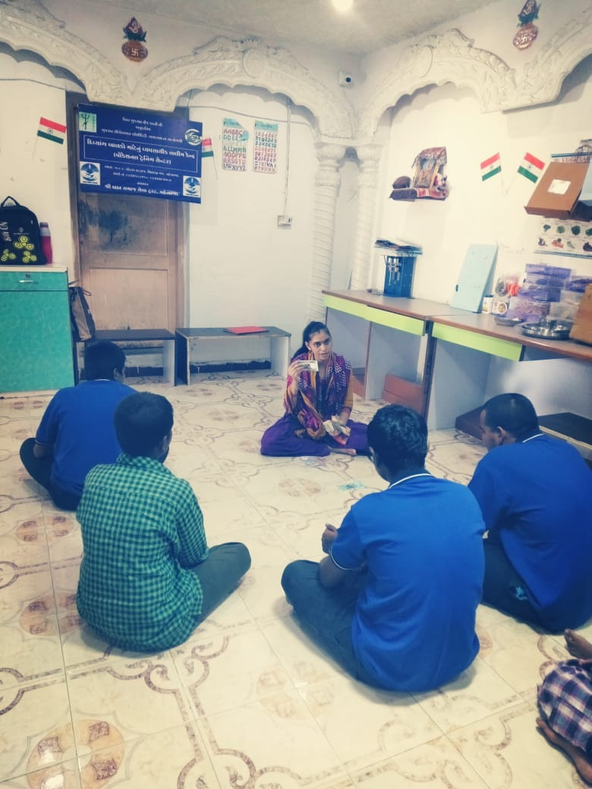

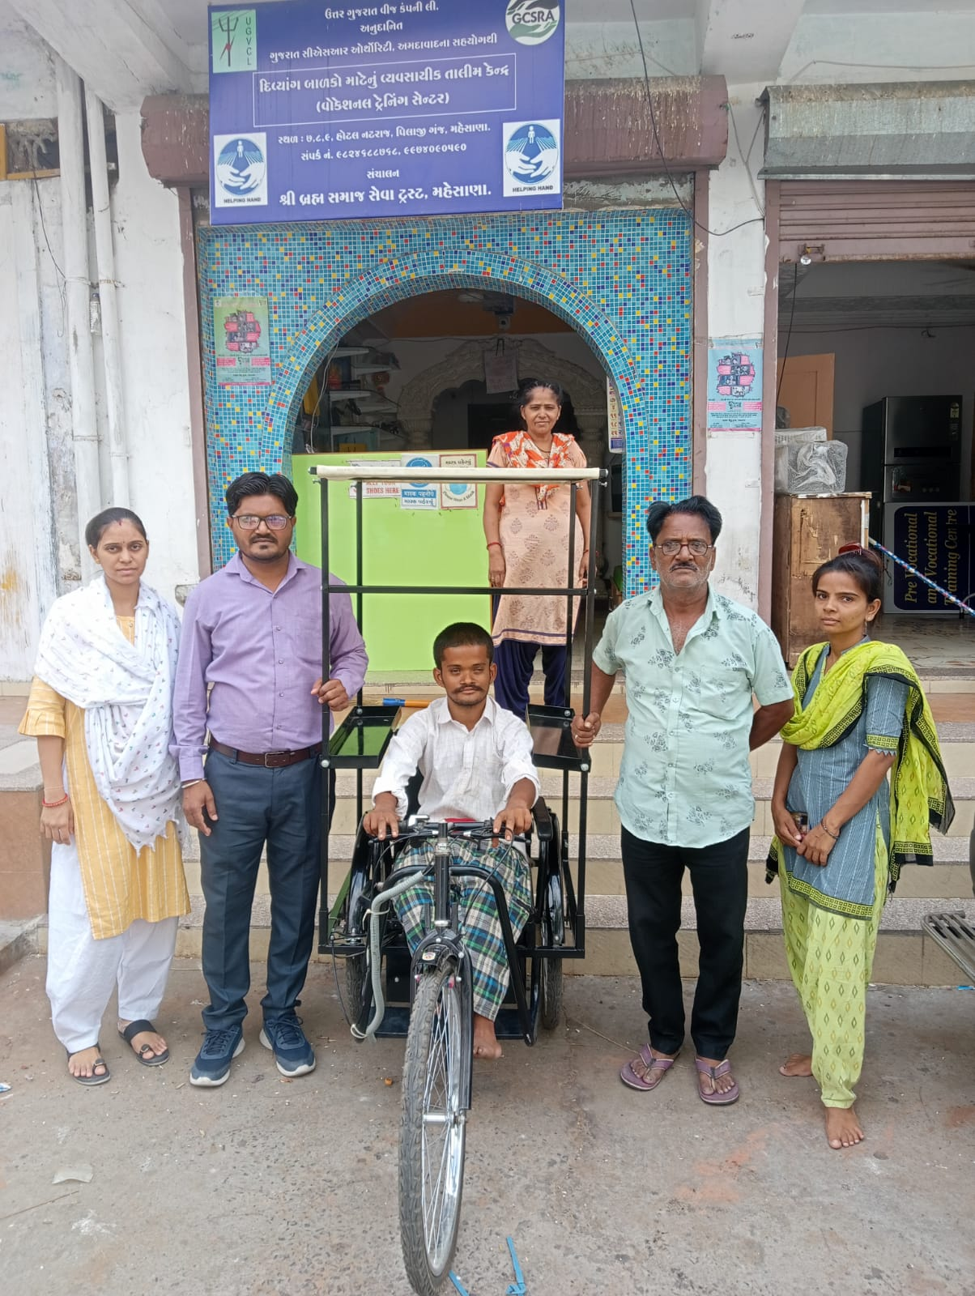

* Parents review meeting was taken and received good positive feedback.

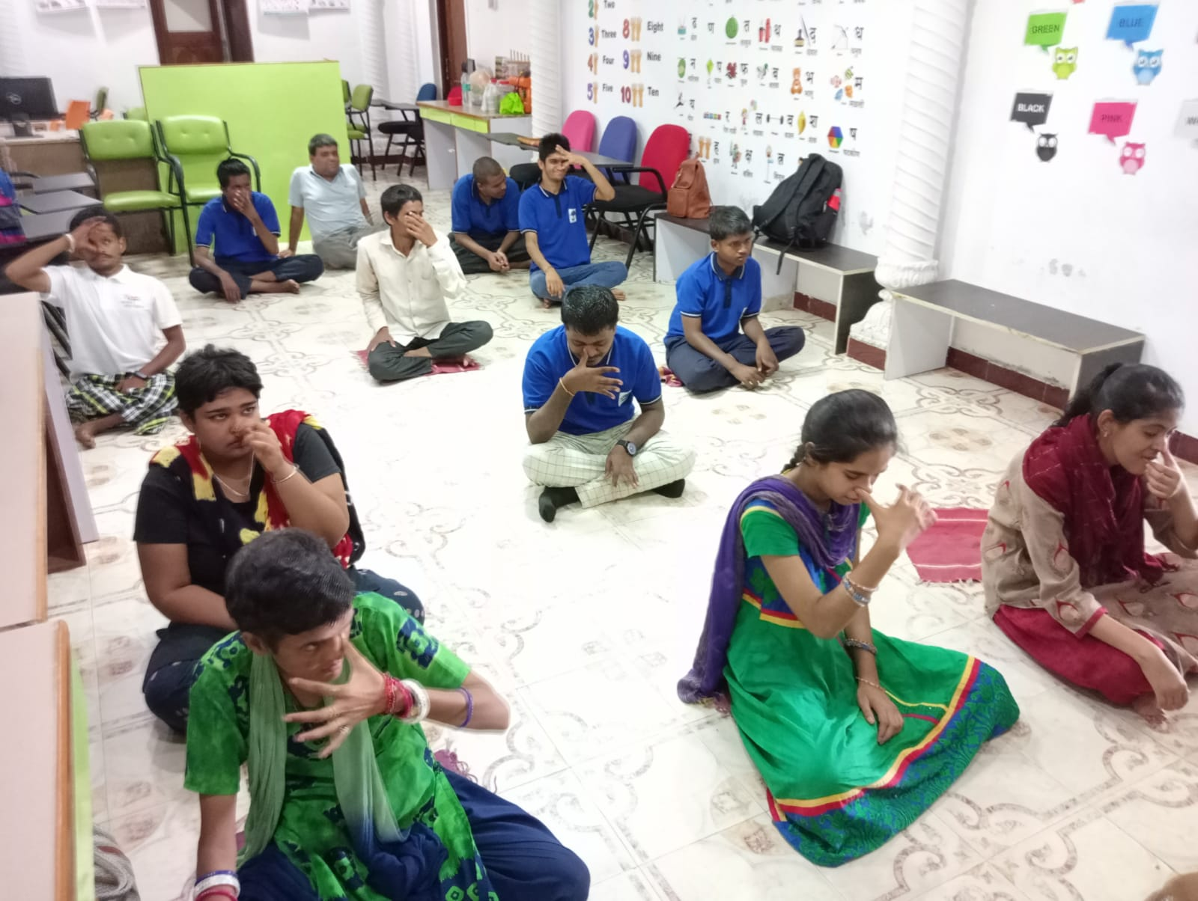

* Agarbati Making and its Packaging, Jewellery making was done
* As a part of community outreach, one of our trainee Mr Sodha Mahipat Singh, was given a modified bicycle to support him in selling his products more efficiently.

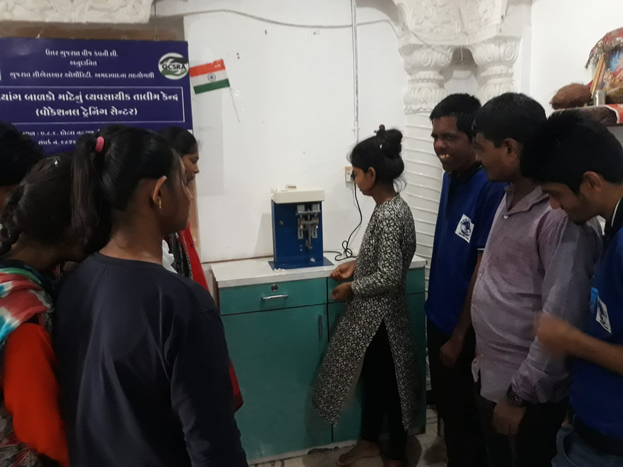

* On the occasion of Yoga Day, trainees were given information about yoga and performed basic asanas like Padmasana, Surya Namaskar, and Anulom Vilom.
* Divit making. Centre was established with the procurement of 2 Divat making machines
* Training of the Divat making machines and its procedure were conducted.
* In-house training was also held for better functioning of the centre

## Quarter 4 - August, 2022 to October, 2022

* Transportation awareness training was conducted to know that how the vehicles run in different medium such as air, water, and land.

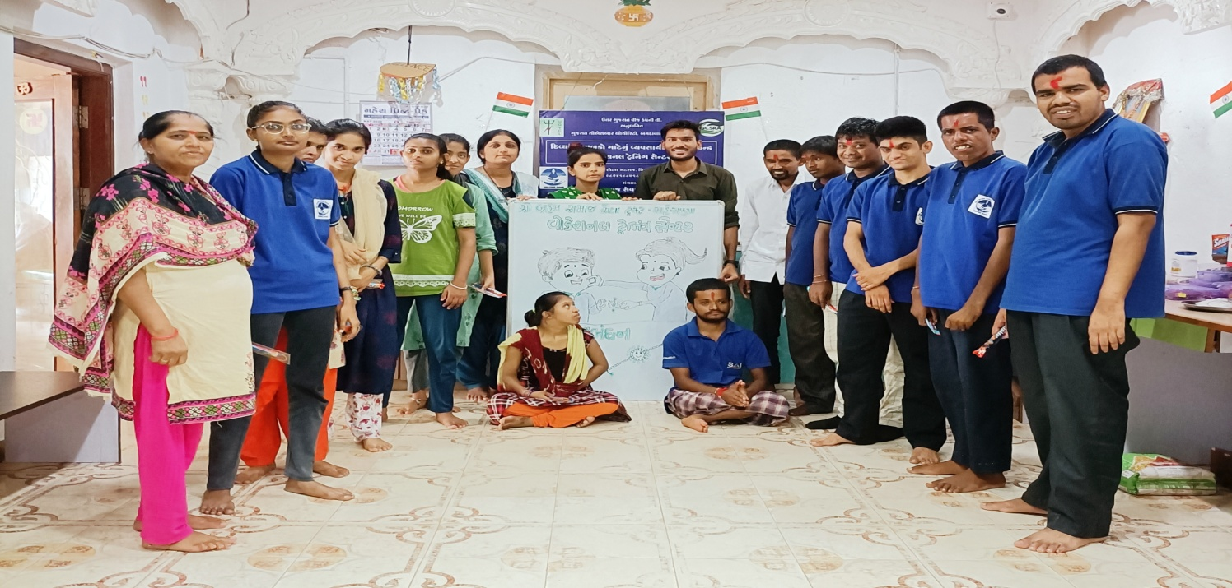

* They have visited rickshaws, scooters, cars, luxury (buses) and discussed about train and air-planes
* Rakhi was also made at the centre and also celebrated the festivals such as Rakshabandhan, 15th August, , Navratri etc.

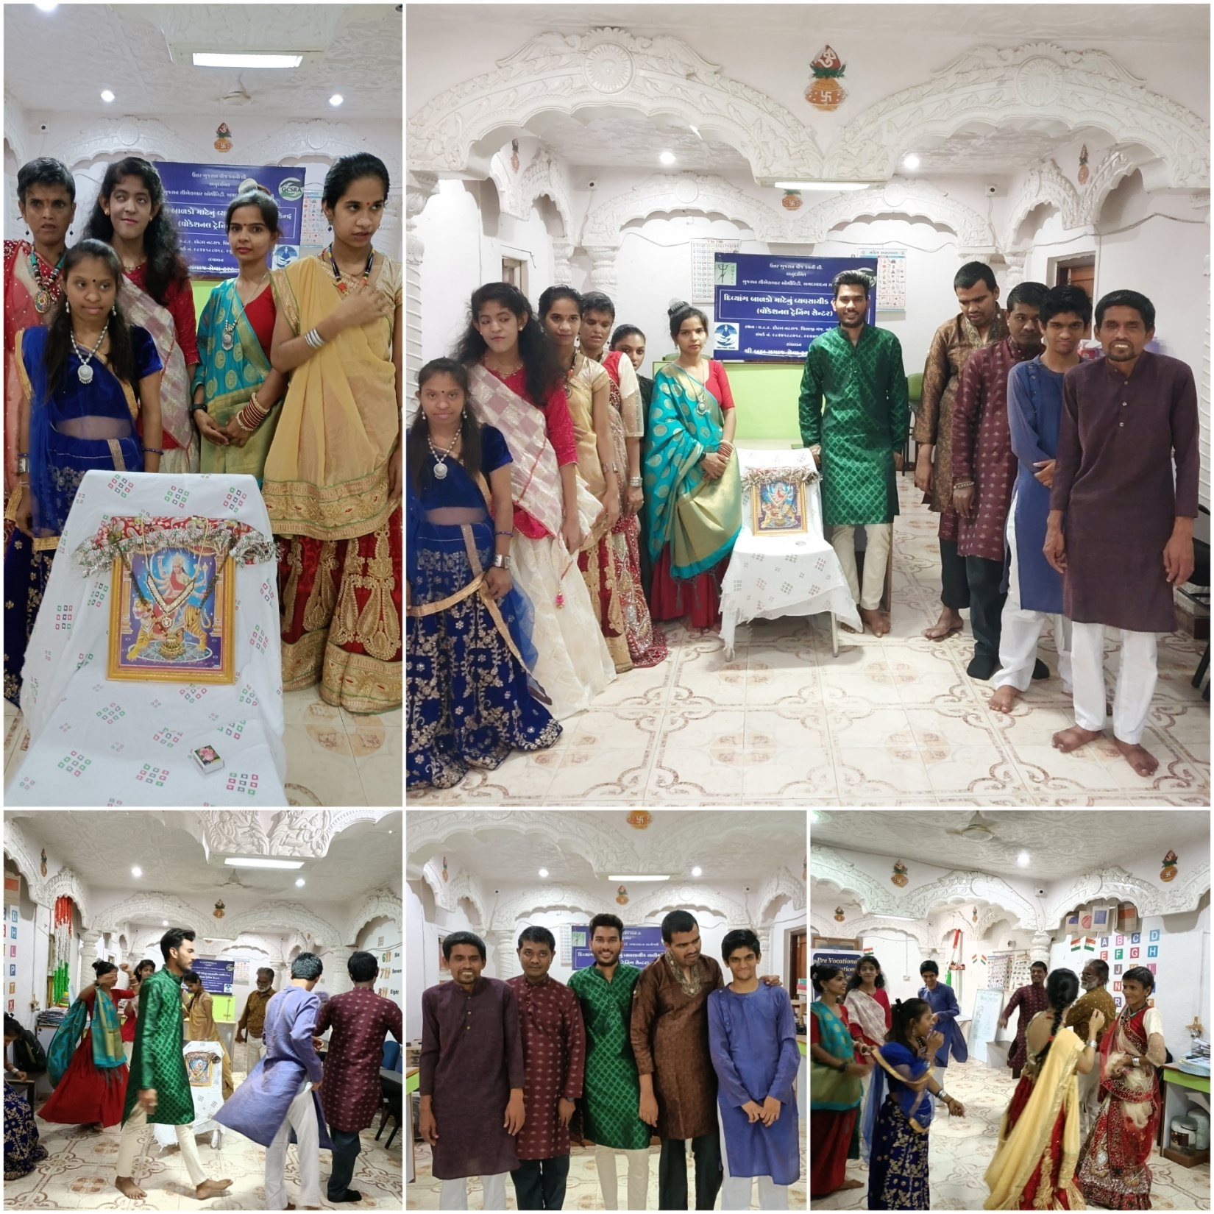

### Rangoli making and Color work on Diyas

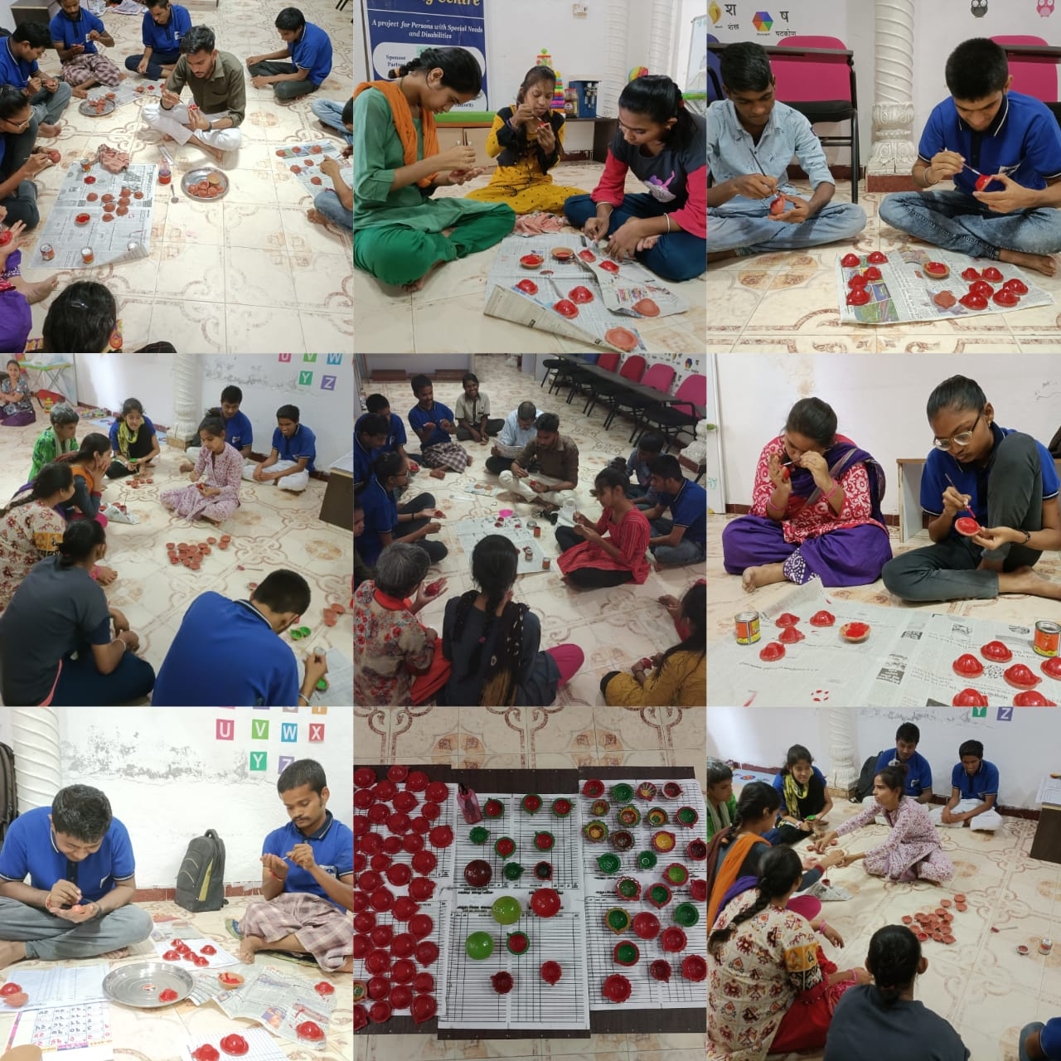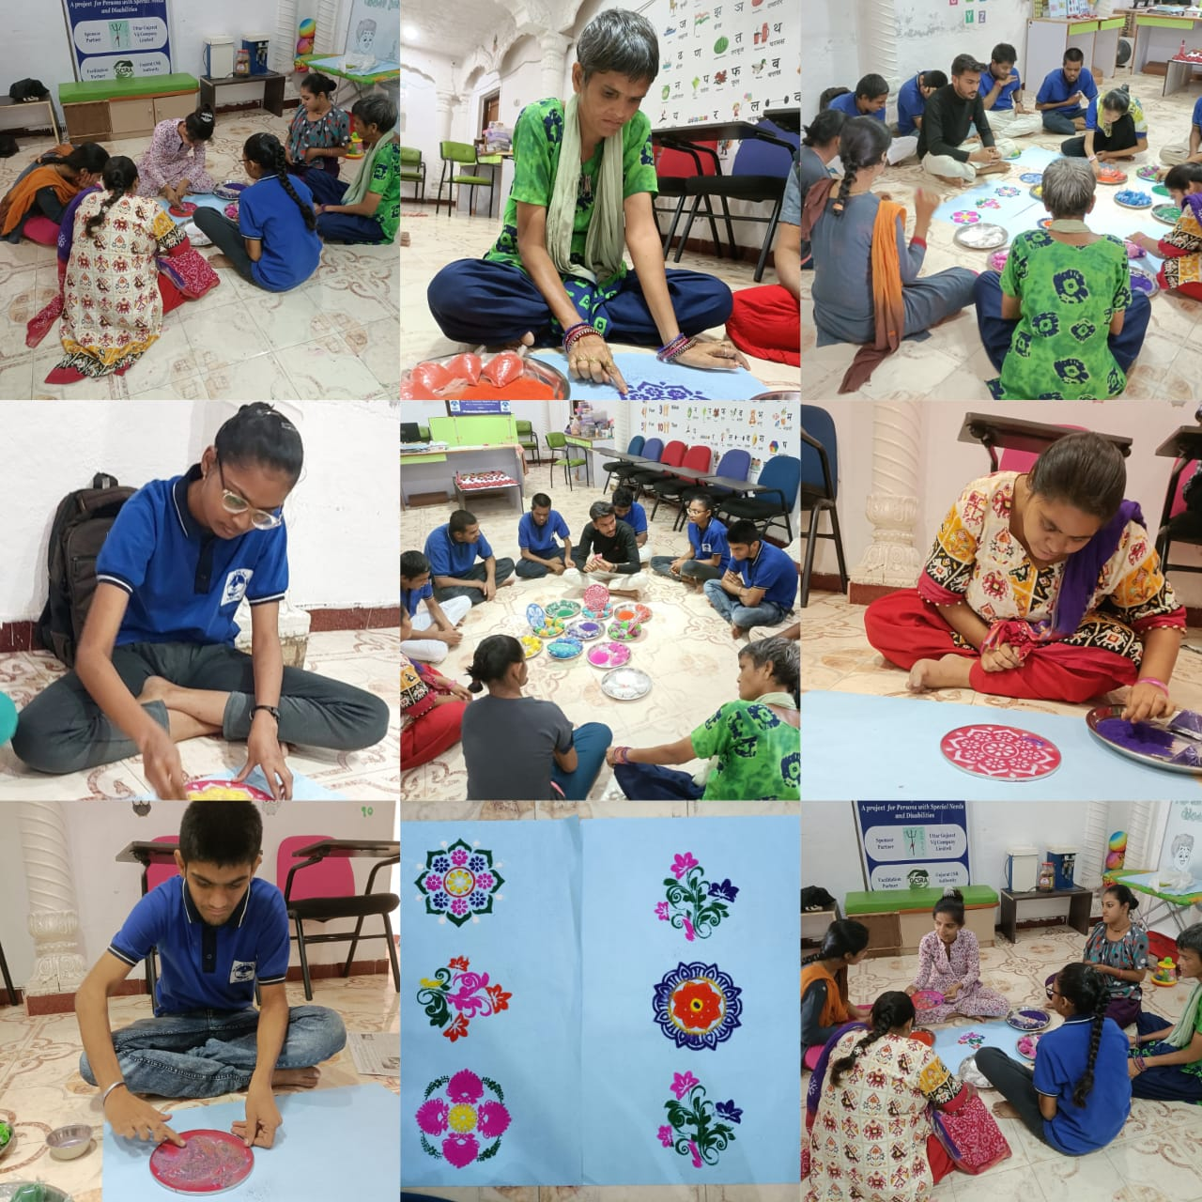

### Selling Centre

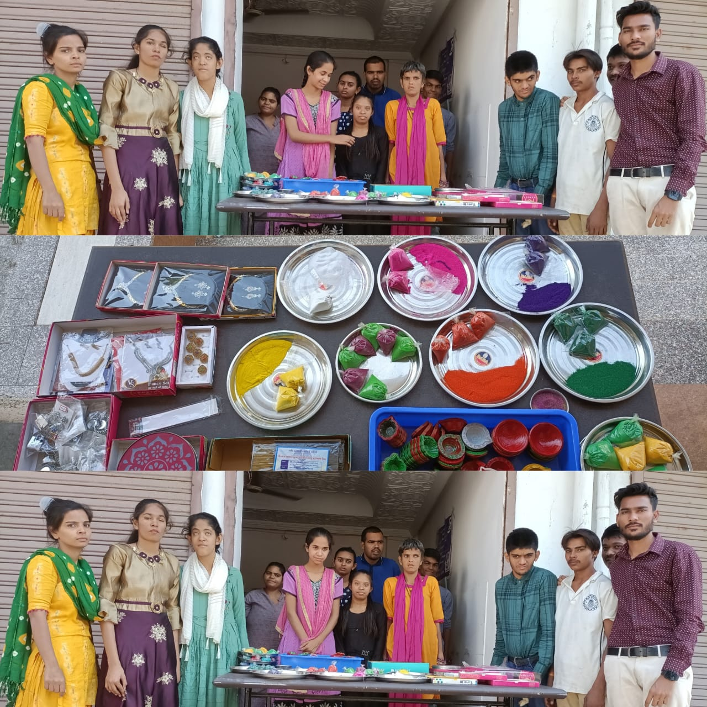

## Work Summary

|  |  |  |  |
| --- | --- | --- | --- |
| **Name of the Activities** | **Number of children/beneficiaries** | **Total Production/Sessions** | **Income from the Vocation, If any** |
| Agarbatti making | 19 | 70 Packet(100 Gram Each) | 1750/- |
| Paper bag making | 17 | 50 Unit | 500 /- |
| Divada making | 19 | 500 Unit | 1250/- |
| Jewelry making | 17 | 25 Unit (Pag ni payal) | 500/- |
| Diwali Colour | 10 | 40 Packet | 200/- |
|
| Total | | | 4200/- |

### Project Team

|  |  |  |  |
| --- | --- | --- | --- |
| **Name** | **Qualification** | **Working experience** | **Salary Offered PM** |
| Rathod Gopalbhai Bharatbhai | M.Com. LL.B. | 12 Years | 25000 |
| Patel Hemankiben kanubhai | B.COM , SP. BED H.I | 2 YEARS | 20000 |
| Senma Savanbhai Amurutbhai | M .A , SP .BED M.R | 3 MOUNTHS | 20000 |
| Acharya Pannaben Jigneshkumar | B.SC , HOME SCI | 3 YEARS | 15000 |
| Nayi Chetanaben Bharatbhai | 10 | 2YEARS | 10000 |
| Joshi Rameshbhai ambalal | 10 | 5 YEARS | 12000 |

### Details of the Parents

|  |  |  |
| --- | --- | --- |
| Name of the parent | Name of the child | Address |
| Prajapati trusha | Vishanubhai | Undi fali no madh tower pase mehasana |
| Pathan farhanabanu | Faridkhan | 36/sanapark soci part-1 shobhasan road mehasana |
| Makavana itesha | Kishorekumar | D/o jantanagar socity mehasana |
| Fakir tanajbanu | Jakirhussain | D/o dediyasan mehasana |
| Takor neha | Gabhaji | Govind madhav ni chali pancha limadi mehasana |
| Malik khursidabanu | Sikandarbhai | Nava vaas kasba mehasana |
| Tank adnan | Abudulgani | Pankhiyavas ,kasba mehasana |
| Thakor suresh | Bakaji | Patawa ni pol jain derasar mehasana |
| Thakor haresh | Bapuji | Boyara vas mehasana |
| Makavana mayank | Gautambhai | S/o 3. Suryodya park socity somanatha road mehasana |
| Vartiya hardik | Ranjendarbhai | Tekara upar kasba mehasana |
| Gosai khushi | Atulbhai | Avdhoot row –house lakhavad road mehasana |
| Jadav alkesh | Prhladbhai | 36/siddhesweri soci amarpara visnagar link road mehasana |
| Prajapati nilesh | Vinodbhai | 13/ punampark socity nagalpur collage mehasana |
| Sodha mahipatsing | Govind sing | 2/41sanjay nagar socity mehasana |
| Patel hepil | Harshadbhai | C-49 tirupati sukan bunglows near rajdhani township society radanpur road mehasana |
| Shah jalpa | Bhadershbhai | 7/virnagar socity s.t workshop mehasana |
| Solanki jigar | Tribhovanbhai | Jetalvasana visanagar |
| Makavana ronak | Narsibhai | Rusi nagar socity |
| Makavana manisha | Narsibhai | Rusi nagar socity mehasana |
| Shekh sarfaraj | Faiyojoddin | Juni mocha vad mehasana |
| Pancholi gauravkumar | Dhruvkumar | 8/sai duplx nr. Parth city ucharpi road mehasana |
| Meman halima | Dilavarbhai | E22/23 alaknanda tenament visanagar road mehasana |
| Chavada kinjal | Narendarbhai | B-7 navadurga nagar mehasana |
| Raval chetankumar | Jayantibhai | 9/ prabhu nagar socity near greenpark modhera road mehasana |

### Conducted Various Activities at the Centre

|  |  |
| --- | --- |
| **Activities** | **Remarks** |
| **Pre-vocational training** | By doing to differentiate a small gem , big gem and pulse and to do identify them and doing exercise of their hands . |
| **Celebration of festivals** | Including Birthday celebration of each students, most of the festivals were celebrated and they felt a joy |
| **Parent’s counseling** | Please, send haresh after his routine and make sure that he has neat and clean clothes and he has his favourite meal too. |
| **Any other activity/program** | The donor donate a huge type of gifts and snacks to the student.  Halima , Mayank , and Suresh are making a very beautiful paper bags  Kinjal , mittal , and neha are also doing good work |

### Students Feedback

#### RAVAL CHETANBHAI NARENDRABHAI

* They are hundred percent blind. They used to sit in Mehsana with weighing forks. And from the time the center came up, every item of the center began to be taken away for sale. So that their financial condition improved and they themselves are thankful to Brah Samaj Seva Trust.

#### SODHA MAHIPATSINH GOVINDSINH

* Mahipat, a fatherless child, used to support himself and his 80-year-old grandmother by selling acid and bleach on a wheelchair. Shri Brahm Samaj Seva Trust gave him an electric bicycle. He and his grandmother are thankful to the center for the purpose of enabling him to travel more distances in less time and earn more money.

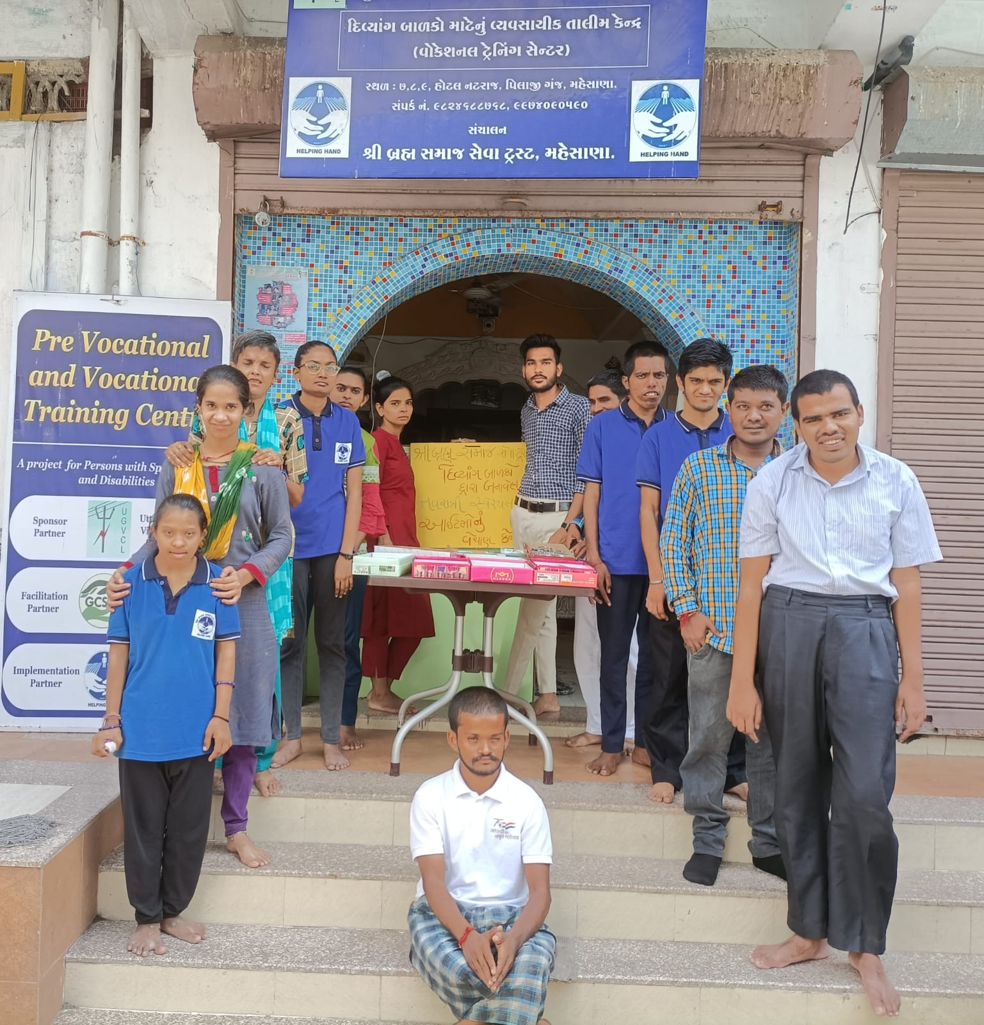

Most of the outcomes has been achieved, trainees has a lot potential to do further work. After increasing awareness and product development related work in first year, we are hoping that this year we growth at the double rate.